Game Design Document

Fill up the Following document

1. Write the title of your project.

MISSION ASTRONAUT

1. What is the goal of the game?

The goal of the game is to save the astronaut who got struck in moon and not able to come back to earth.

1. Write a brief story of your game?

One day, an astronaut went to moon for a mission. After completing his mission, he noticed that his space ship had a malfunction which he got struck and not able to return back to earth. Another astronaut got this news from space station and he was ready to save him. He started his journey and he faces lots of difficulties like aliens, asteroids and thunderstorm. After facing all these challenges the astronaut saves another astronaut in moon and returns back to space station.

1. Which are the playing characters of this game?

* Playing characters are the ones which respond to the user based on the input from the user
* Cars, monkeys, dinos, wizards etc, are the playing characters in the game.

|  |  |  |
| --- | --- | --- |
| Number | Character Name | What can this character do? |
| 1 | Astronaut in Space Ship | The character travels to moon and destroys obstacles coming on its way |
| 2 |  |  |
| 3 |  |  |
| 4 |  |  |
| 5 |  |  |
| 6 |  |  |
| 7 |  |  |
| 8 |  |  |

1. Which are the Non Playing Characters of this game?

* Non Playing characters are the ones which don't have an action or a behaviour when the user interacts with the game.
* Hurdles, stones, bananas, coins, etc are non playing characters in the game.

|  |  |  |
| --- | --- | --- |
| Number | Character Name | What can this character do? |
| 1 | Aliens | Tries to destroy space ship |
| 2 | Asteroids | Tries to destroy space ship |
| 3 | Thunderstorm | Can struck in space ship |
| 4 | Astronaut who got struck in moon | Wait for another astronaut to come and save him |
| 5 |  |  |
| 6 |  |  |
| 7 |  |  |
| 8 |  |  |

Draw your imagination of this game. What does this game look like?

* Draw the game either on your computer or on paper,
* Add images of scenes of the game to show each of the playing and non-playing characters at least once.

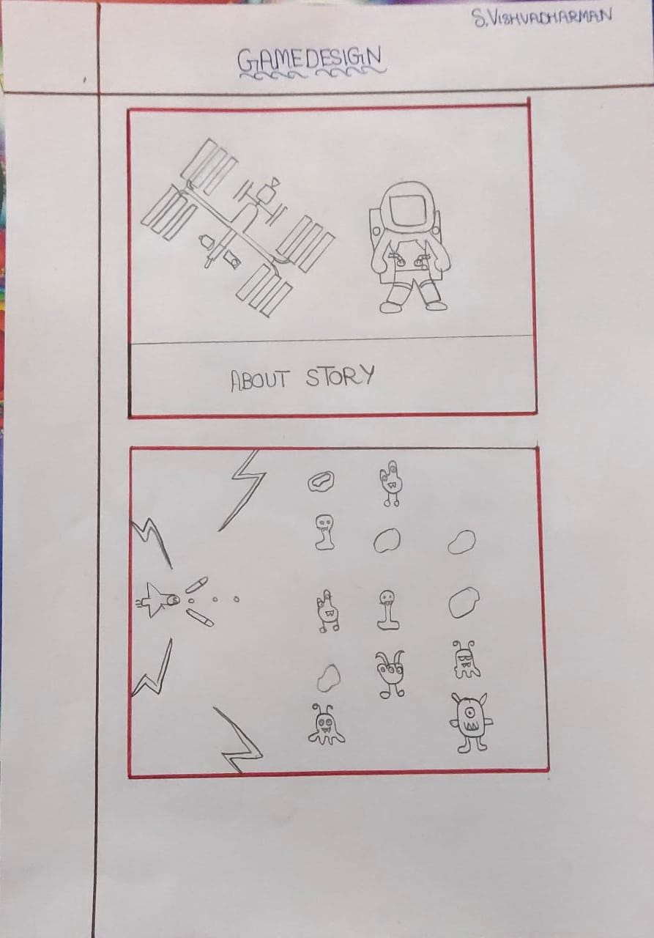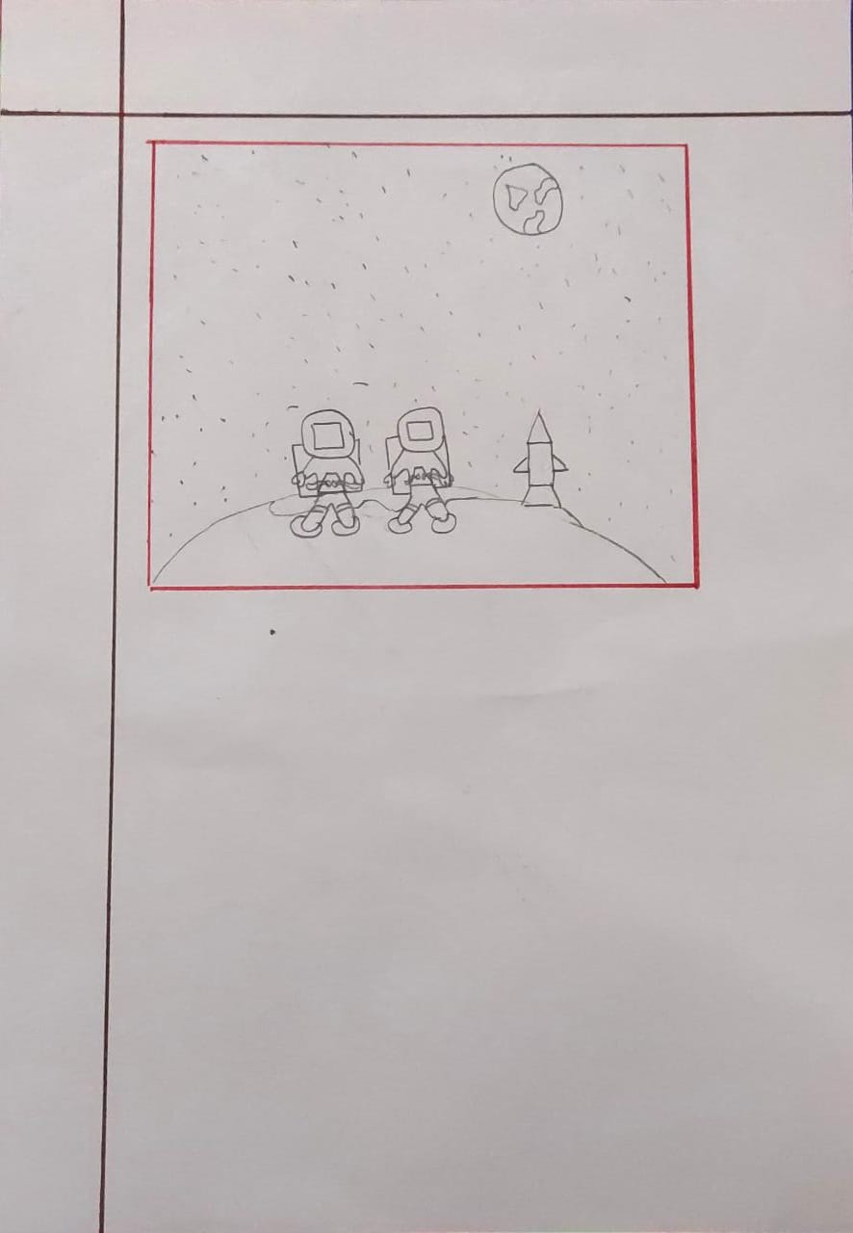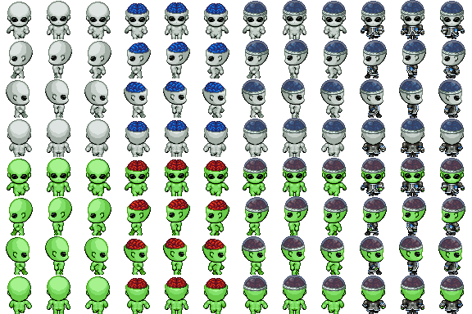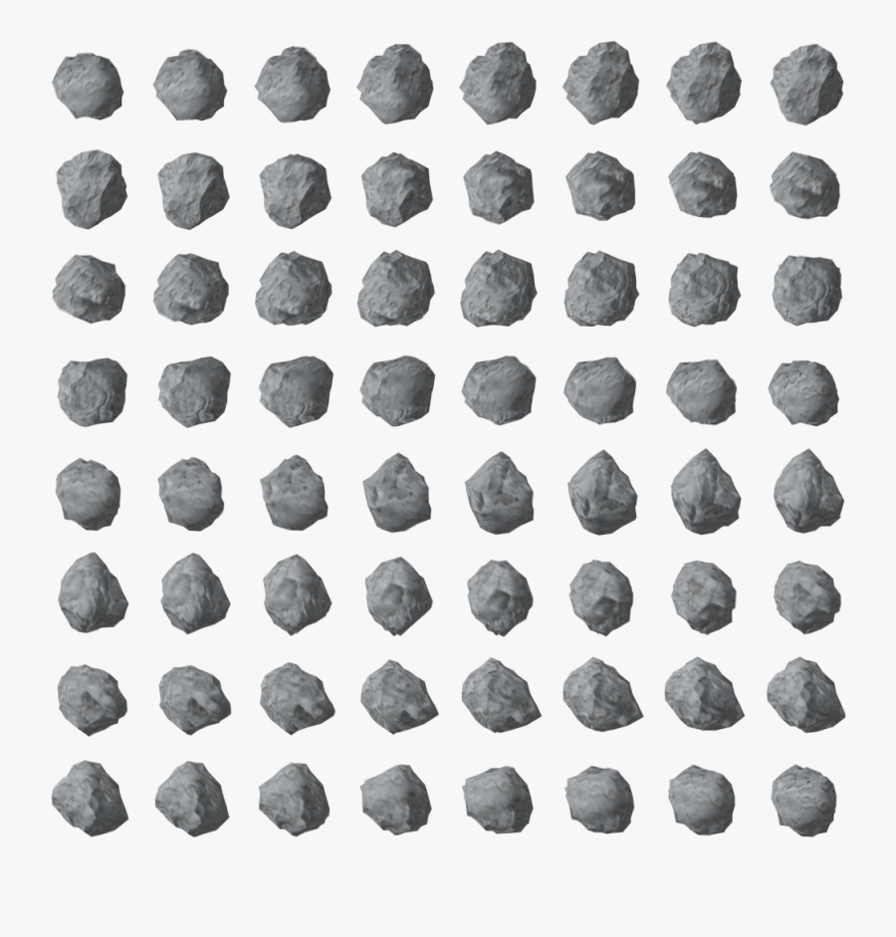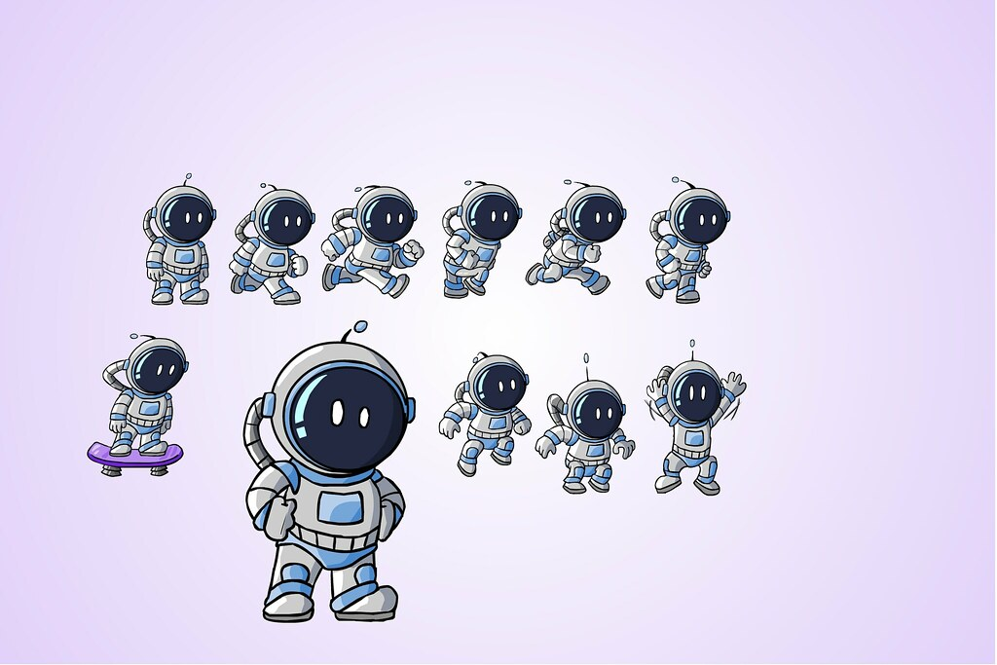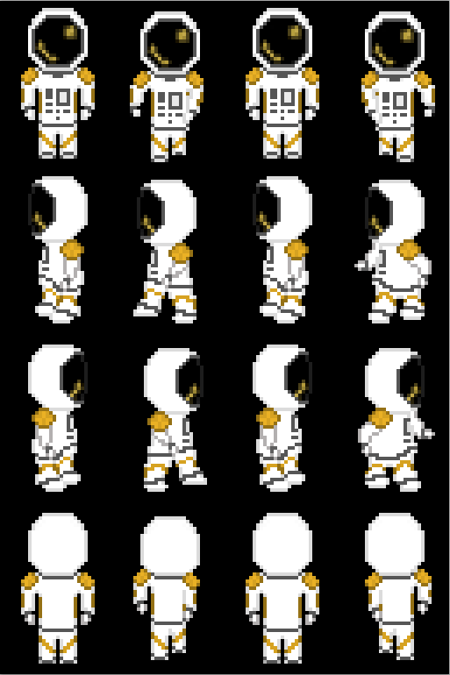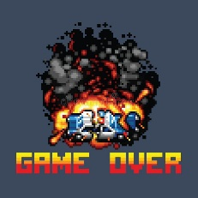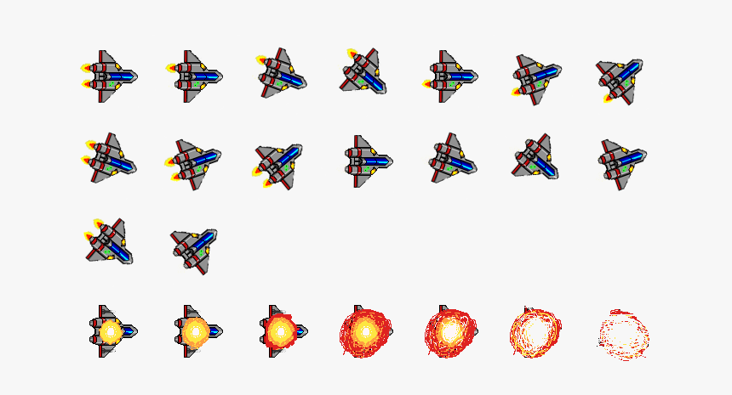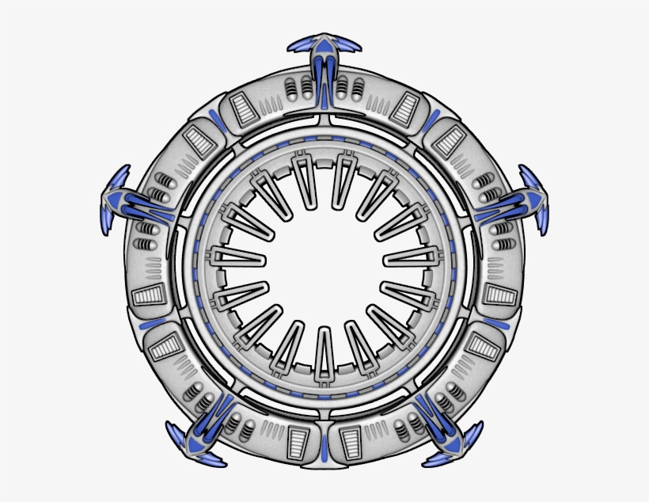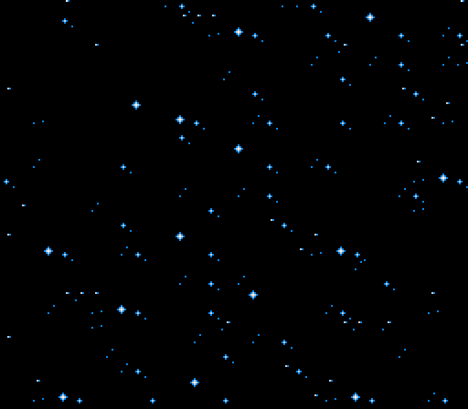

How do you plan to make your game engaging?

When the game starts many obstacles will be coming in the path of the space ship and we need to destroy and the speed of the space ship starts to increase after destroying 10 obstacles. When the aliens come we need to play a sound shoot and the player shoots the aliens by pressing ‘s’ key.

When the space ship reaches the moon, both the astronauts meet and finally come back to space station.